**HOME FINDS YOU: A WEB BASED PROPERTY RENTAL PLATFORM TO ADDRESS HOUSING ISSUES**

By

Anne Sharon Wanjiru Nyamu

150805

A Project Documentation Submitted to the Strathmore Institute of Management and Technology in partial fulfilment of the requirements for the award of Diploma in Business Information Technology.

Diploma in Business Information Technology

**Strathmore University**

June2024

**Declaration and Approval**

I **Anne Sharon Wanjiru Nyamu** declare that this project has not been submitted to any other University for the award of a Diploma in Business Information Technology.

Student Name: **Anne Sharon Wanjiru Nyamu**

Sign: ________________________ Date: ________________________

Supervisor’s Name: **Fredrick Barasa**

Sign: ________________________ Date: ________________________

**Abstract**

Finding a house or accommodation that ticks all personal boxes is a long, tiresome and expensive process that can be quite stressful and draining, as it involves physical visits and contacting of multiple agents. Housing is a major problem in the country affecting majority of the people at large. This project aims to assist in the house hunting process through a web-based application, aimed at improving cost and time management. This will be done by automating the search process, to ensure users easily navigate and find their ideal homes. Instead of having to physically go to various locations looking for a house, the house is ‘brought’ to the palm of your hand.

Several initiatives have been taken in the accommodation sector like Airbnbs, motels, hotels and lodging etc. Other existing solutions are student accommodation sites. However these are all temporary solutions, Home Finds You system aims to create a permanent / long term solution to housing needs thereby bridging the gap.  
This platform includes a user-friendly search interface, standard security features as well as seamless integration with other systems. To develop this, Agile Methodology will be used as it prioritizes collaboration, adaptability and customer feedback. Object-Oriented Analysis and Design (OOAD) will also be used as it allows modular, flexible and maintainable design, making it easier to manage complexity and accommodate future changes in the system.

**Table of Contents**

**Declaration and Approval** ii

**Table of Contents** iv

Chapter 1: Introduction 1

1.1 Background 1

1.2 Problem Statement 2

1.3 General Aim 3

1.4 Specific Objectives 3

1.5 Research Questions 3

1.6 Justification 4

1.7 Scope 4

1.8 Limitations 5

1.9 Delimitation 5

Chapter2: Literature Review 6

2.1 Introduction 6

2.2 To review existing housing/accommodation systems and their shortcomings 6

2.2.1 Numerous existing systems 6

2.2.2 Individual / private ownership sites 7

2.2.3 Temporary accommodation solutions. 7

2.3 To review challenges faced by existing accommodation systems 7

2.3.1 Legal disputes / security 7

2.3.2 Illegal behaviours by tenants / renters 8

2.2.3 Payment / renumeration issues 8

2.4 To review the existing solutions and their functioning 8

2.4.1 Airbnb 8

2.4.2 System 2 Hotel bookings 9

10

2.4.3 System 3 Student accommodation 10

10

2.5 Conceptual Framework 11

Chapter 3: Research Methodology 12

3.1: Introduction 12

3.2: Iterative and Incremental development methodology 12

13

3.2.1: Requirements Engineering 13

3.2.2 System Design 13

3.2.3 System Development 14

3.2.4 Testing 14

3.3 Implementation 14

3.4 Deliverables 14

3.4.1 System Modules 15

3.4.2 Users and User roles 15

3.4.3 System Architecture 15

Chapter 4: System Analysis and Design 17

4.1 Introduction 17

4.2.1 Functional Requirements 17

4.2.2 Non-Functional Requirements 17

4.3 System Design 18

4.4 System Analysis Diagrams 18

4.5 System Design Diagrams 18

4.5.1 Use Case Diagram 18

19

4.5.2 System Sequence Diagram 19

20

4.5.3 Activity diagram 20

21

4.5.4 Class Diagram 21

4.5.5 Database Schema 22

4.5.6Wireframe 23

23

` Chapter 5: System Implementation Testing 24

5.1 Introduction 24

5.2 System Implementation 24

5.2.1 Systems backend 24

5.2.2 System’s front end 26

5.3 System manual 30

5.3.1 Admin screen 31

5.3.2 User screen 32

5.4 System Testing 33

5.4.1 Black box testing 33

5.4.2 Functionality testing 33

5.4.3 Unit testing 33

5.5 Test Cases 34

5.6 Test Results 34

Chapter6: Conclusions and Recommendations for Future Work 36

6.1 Conclusions 36

6.2 Recommendations 36

6.3 Future Work 36

References 37

Appendix A: Gantt Chart 39

**List of figures**

Figure 1Airbnbsystem 9

Figure 2 Hotel Techsystems 10

Figure 3Hostel systems. 10

Figure 4 Conceptual framework 11

Figure 5 Iterative development methodology 13

Figure 6 Use case diagram 19

Figure 7 Sequence diagram 20

Figure 8 Activity diagram 21

Figure 9 Class diagram 22

Figure 10 Database schema 23

Figure 11 Wireframe skeleton 24

Figure 12 Wireframe 24

Figure 13 Admin log in code snippet 26

Figure 14 User log in code snippet 26

Figure 15 Admin view code snippet 27

Figure 16 Home page code snippet 28

Figure 17 Admin dashboard code snippet 29

Figure 18 User dashboard code snippet 30

Figure 19Admin log in site 31

Figure 20User registration 31

Figure 21 User log in 32

Figure 22 Admin screen 32

Figure 23 Users homepage 33

Figure 24 House details 33



# Chapter 1: Introduction

## 1.1 Background

Home Finds You addresses the issue of inadequate housing and city planning. This is a social problem affecting people at large. Housing / settlement is a key aspect of the society / community we live in. A survey done in 2023 statistics showed there are about 500,000 homeless people in Kenya, this is a wanting problem that the project aims to address. This is because homelessness leads to a high level of insecurity and a decline in public health and psychological wellbeing of the people. It also affects the country’s revenue and work force. Instability and insecurity in the housing sector, has a strong detrimental impact to any person as shelter is one of the core basic needs. This affects the individual in all areas of their life and affects their community as well. If this problem is left unaddressed it continues to grow and become an even bigger menace as the numbers increase. This project aims to make finding a house an easier process consequentially creating opportunities for more accommodation to be constructed and slowly reducing the rate of homeless people by providing a means of earning as well.

Lack of proper housing is caused by poor urban planning by the government, inadequate housing, low economic status and scarcity in available options. Surveys and statistics compilations by United Nations and Kenya Bureau of Statistics among other organisations, confirm this is a dire problem via methods like the national census. According to the census done in 2019, Kenya’s population is 47.5 million or 12.2 households with 61.3% owning homers and 38.7% renting. The main suppliers of rental housing are individual investors with 88.5% rental units nationally, 6% by private companies. The Public sector for housing (National government, County government and Parastatals combined) provide very little rental stock compared to private companies (rate of 4.7% combined). The population density of Kenya in 2019 was 82 people per square kilometre. Total Households were 12,143,900 households, and the average household size was 3.9 people. Hotels and bed-nights (motel/Airbnb’s) occupancy rose by 27% in 2022. Little to no attention has been given to producing affordable housing to the poor segments of the population, who form the bulk of Kenyan society – 53% as of the end of 2020. As a result, over 60% of urban households in Kenya, are people living in slums where they still struggle to raise enough money per month for rent.

Across Africa, governments are trying to tackle the challenge of affordable housing. The focus has been on mechanisms to stimulate delivery of affordable housing for very low-income earners. Governments have tried various strategies with varying degrees of success. Complementary demand-side strategies aimed at matching the target population to the housing produced, have also been tried. The Affordable Housing Programme (AHP), launched by the Government of Kenya in December 2017, with an ambitious target of providing 500 000 housing units over a five-year period, is a recent effort by the previous government. It involves several incentives and supports to enable the delivery of affordable housing in Kenya. The first project in the programme (Nairobi’s Ngara Estate) has so far delivered 228 affordable units. It has created extensive opportunities for investment in construction, and the manufacture and supply of building materials and components. But it faces various challenges which will have to be overcome if the programme is to succeed.

In Kenya, the right to housing is embedded in the constitution which provides that “Every person has the right to accessible and adequate housing, and to reasonable standards of sanitation.” Home Finds You system is a solution created to uphold these rights, indirectly curb this crisis and aid in development. By creating an application that makes finding a house an easier and more efficient process, it reduces the rate of people lacking stable housing, it creates employment, it encourages construction of more housing and consequently reduces / replaces the slum settlements. The application also provides employment opportunities and business opportunities as more households are constructed. This project can be implemented in the Affordable Housing Programme (AHP) to rent out houses faster, increase demand, increase construction rate and eventually reduce the rate of homelessness and slum encroachment.

## 1.2 Problem Statement

Housing is a major issue in the society due to overpopulation and under planning by the government. This problem affects everyone at large regardless of sex or age but especially the lower- and middle-class citizens of this country. This is because the lower income citizens are constrained by their budget to find a house and do not have a lot of options to choose from let alone locating the houses. This becomes an even bigger problem in times of natural calamities such as heavy rain / floods witnessed earlier this year or when there is a high level of insecurity in an area.

This affects the community at large since housing is a social determinant of health and wellbeing. Poor housing / planning leads to overcrowding, encroachment of slums, poor sanitation, poor state of living and raises the rate of insecurity as people struggle to make ends meet. Studies by the National Institute of Health show the psychological impact of not having a suitable home, this leads to decline in mental health and overall wellbeing as poverty is one of the greatest vices that have such a big impact on people. Poor housing also leads to increased homelessness, increases the burden on public services, loss in the country’s revenue and increased cost of healthcare.

## 1.3 General Aim

Home Finds You system aims to create a web application system that enables easy access to available housing. By creating a virtual connection between the tenants and aspiring residents, the application bridges the big gap between the two. Locating an area where you would live and houses within your budget will be made easier by the application. This system will lead to better housing / urban planning and lower income individuals will find it easier to locate houses. This system aims to solve the issue of urban planning, overcrowding, potential homelessness, psychological wellbeing of people and loss of government revenue. This will also solve joblessness to a degree by creating employment for people such as the renters, contractors, architects, masons to build more houses, and agents used by renters etc.

## 1.4 Specific Objectives

i. To review how existing housing/accommodation systems work, their key features and shortcomings e.g. Airbnb accommodation system

ii. To review challenges faced by existing housing/accommodation systems, more so in searching and locating them, occupation process and customer satisfaction.

iii. To review and compare the existing housing/accommodation technologies and assess their functioning and needed areas of improvement.

iv. To design and develop an accommodation solution/ system that works to ease the house hunting process troubles.

v. To test the developed solution to ensure its working to meet the functional requirements and performs to meet the users’ needs.

## 1.5 Research Questions

i. How do existing housing/accommodation systems work? What are their features and areas of shortcomings?

ii. What are some of the challenges faced by existing housing/accommodation systems in searching and locating them? How is the occupation process and customer satisfaction rates?

iii. How are the existing housing/accommodation technologies functioning? What are the needed areas of improvement.

iv. How to design and develop an accommodation solution/ system that works

v. How to test the developed solution to ensure its working to meet the functional requirements and user needs.

## 1.6 Justification

Home Finds You system is a project that would lead to better urban planning by the government and increase the availability of housing, as this is a major issue in the country. By creating this web application more people will be able to access housing, hence increase in usage of the app and therefore demand in accommodation. This will lead to more building and construction of apartments/ accommodation.

This creates employment to the contractors, masons, NEMA officials, tenants among other people directly or indirectly. This also benefits citizens as the country’s revenue increases, better urban planning, reduction in insecurity and better environment and living conditions. This could eventually lead to decrease in slum settlement with the slums replaced with proper housing, increase in public health and overall quality of the environment. The government would also raise its revenue with the construction of houses, which will later call for construction of roads, and this opens various opportunities for business and market. This would also reduce the impact of natural calamities like floods, reduce the rate of homeless people on the street, reduce insecurity and raises the general wellbeing of people. Psychological well-being of people would also increase, creating a better work force and a more harmonious country.

## 1.7 Scope

The project will be a two-end user system, where the administrator of the system can receive advertisements of vacant accommodations, post the available houses and the people looking for homes can go to the site and search for their preferred houses. There will be filters available where you key in what type of accommodation you want, this could be student accommodation, an apartment or a stand-alone house. You can also key in the range of the rent you are willing to pay, the number of rooms you would like, and the app will show you available houses according to the terms you keyed in. There is also an option for you to contact the renters directly in case of any queries or if you would like to proceed with the accommodation process. There will be no payments or required money transactions via the app to ensure safety and prevent theft of personal information, spam or conmanship.

## 1.8 Limitations

The app may contain cyber criminals who aim to steal information or coerce the people looking for houses for selfish gains. The app may have conmen who aim to solicit money out of people with no available housing present or people double gaming others and renting out one house to multiple people.

## 1.9 Delimitation

The web application will require all users to have an account hence everyone’s information is captured by the app in case of liability. The application will not ask for excessive personal information for user profiles to limit damage in case of a cyber-attack. No money transactions would be made via the app or requested. Payment will be a personal contract / agreement by the tenant and landlord off the application upon occupation.

# Chapter2: Literature Review

## 2.1 Introduction

This chapter goes over how accommodation systems have been working to date. It discusses the current solutions in housing/accommodation systems and the gaps in these solutions. It also gives an overview of how the accommodation system (Home Finds You) is going to work upon implementation. Technologies such as Airbnb systems, student hostel systems and hotel booking systems have been created using various technologies. However, the existing solutions face various challenges such as breaching of contracts by tenants who fail to pay up, security issues like illegal activity and cybercrime, poor maintenance with the major common disadvantage being all of them being temporary solutions to accommodation/housing needs. Home Finds You aims to create a solution that is more long term for housing needs and aims to reduce issues like cybercrime and conmanship on such platforms. The system will be a simple interface where users can create accounts and search for their desired housing needs.

## 2.2 To review existing housing/accommodation systems and their shortcomings

This section aims to analyse and review how existing housing/accommodation systems work, their key features and shortcomings e.g. Airbnb accommodation systems, hotels, motels.

### 2.2.1 Numerous existing systems

Current systems in finding accommodation are numerous and each is in different sites instead of one main integrated system that encompasses all the available options (Accommodationsnairobi). There are multiple sites posted by individuals either on social media or in the search engine in efforts to advertise their places. Most of these sites have outdated information or misinformation. There is no coherent order of information, false details and are opportunities for cyber criminals to find vulnerable culprits. (cloud suites, 2003)

### 2.2.2 Individual / private ownership sites

Most of the existing functional systems are private owned or individual this creates numerous sites to visit when looking for a viable option instead of them being found under one integrated site. (Accommodationsnairobi) (hotel rooms, 1999-2024 )This creates a hectic process of browsing and switching through multiple sites trying to find the right fit. Most sites being unattended or outdated with wrong information. The existing functional ones are limited and offer a narrow range of options. (Hotels, 1996)

### 2.2.3 Temporary accommodation solutions.

Existing accommodation sites are mostly temporary / situational options like Airbnb’s and lodgings. There are no permanent / long term rental options for adults / family trying to relocate or settle down. (khweza, n.d.) (Airbnb, 2024)

## 2.3 To review challenges faced by existing accommodation systems

Existing accommodation sites face several challenges in their functioning / running such as insecurity breaching of agreements/contracts etc. Challenges presented in the accommodation systems are discussed below.

### 2.3.1 Legal disputes / security

Legal issues such as privacy of client information and data creates an issue where data protection might be a threat. Data protection and confidentiality is at a risk as cyber criminals may try to steal people’s private details to use for malicious purposes to benefit them. Also, clients’ information may be at risk as private information such as their details, their location etc may be sold or may be required by the government for local regulations to be enforced. The physical locations or abodes of the clients may also be at risk of invasion. (fedansolutions, 2019) (ScitechCentral, 2024)

### 2.3.2 Illegal behaviours by tenants / renters

Tenants / contractors may try to evade tax regulations or avoid background checks, and sanitation approvals. The government has a sector (NEMA), responsible for the approval of buildings and their living conditions, which some renters may try to avoid these regulations. (NEEMA, 2024) Renters may subject their tenants to mouldy/ rodent infested conditions, invasion of privacy online and physically. They might also double deal clients where they don’t receive the promised accommodation. (UON, 2020) Tenants may also conduct illegal activities in their places disrupting others or breaking laws/ rules. Innocent people may also fall victim to illegal activities carried out by people involved in the business. (kenyageographic, 2024)

### 2.2.3 Payment / renumeration issues

Payment of rent or service fees can be a target for scammers with intentions of ripping off people by somehow providing wrong payment details or hacking into people’s private accounts/ banking systems with aims to rob them. (kenyageographic, 2024) (airbnb issues&sol, 2021) Tenants may also raise problems when they fail to pay the landlords or delay payment for too long. Some may try to get away without paying after staying in the accommodations. (ScitechCentral, 2024)

## 2.4 To review the existing solutions and their functioning

Existing functional accommodation and housing systems apply various and vast technologies and functionalities in their creation and application. Here we discuss their technicalities and needed areas of improvement

### 2.4.1 Airbnb

Airbnb’s are a type of temporary accommodation company operating an online marketplace for short- and long-term homestays and experiences. Airbnbs stands for a bed and breakfast and the application solves the problem of a temporary overnight stay. The company acts as a broker and charges a commission from each booking. Airbnb uses a diverse range of technologies to drive its operations e.g. Ruby on Rails: This forms the backbone of Airbnb’s technology stack. Ruby on Rails is known for its simplicity and ease of use, making it easier to manage complex codebases and accelerate development process, java, react etc Choice depends on scalability reliability efficiency etc. However, Airbnb’s do not cater to long term accommodation options and face issues with customers (https://community.withairbnb.com) (airbnbtech, n.d.)

.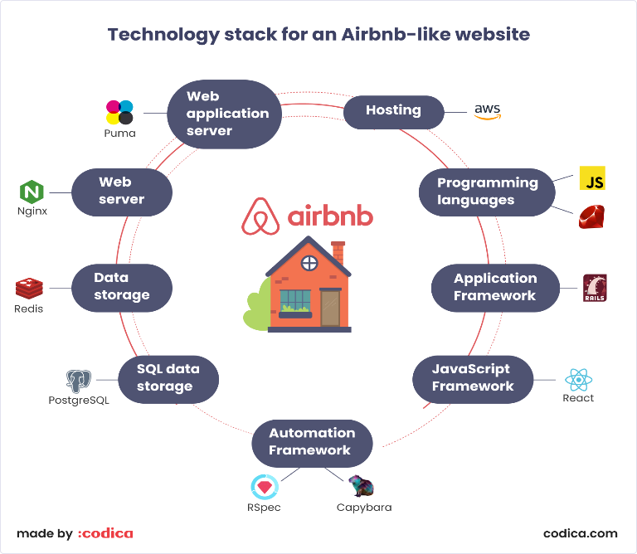

Figure 1Airbnbsystem

### 2.4.2 System 2 Hotel bookings

Hotel booking systems are a type of temporary accommodation where reservations can also be made online or in person. Hotels, motels, lodgings and the like use the same principle as bnbs where the stay is temporary but may be longer than a bnb; one can stay for a week or so depending on your budget. (EAexperience, 2020) These options are not long term resident areas either. Hotel booking systems use various technologies e.g. Reservation management system, channel managers, customer relationship management, APIs etc. (hotel.tech, 2024)

Figure 2 Hotel Techsystems

### 2.4.3 System 3 Student accommodation

Students’ accommodation system is a type of temporary accommodation for students to book hostels for their stay per semester. Few hostels have their own independent system outside of the school’s system, most are integrated with the respective school’s system for their students. The system uses MySQL for the manipulation and storage of data, PHP to create dynamic Web pages and Sublime Text as the integrate development environment/text editor for HTML/CSS and PHP. The proposed algorithm and techniques for automatic student hostel allocation system perform the task of allocating student to hostel rooms and provides information about the room occupancy at any given time, enabling the management in making decisions to improve condition of living in hostels and grants the hostel management team the statistics they need on the hostel. However, this is also a temporary mode of accommodation and available for students only not the common citizen. (hostelstechsyst, 2023)

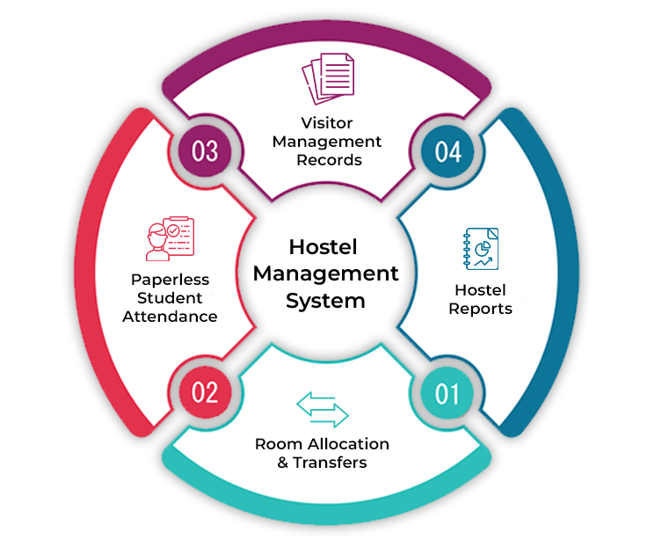

Figure 3Hostel systems.

## 2.5 Conceptual Framework

Home Finds You is a web-based system that offers a simplified virtual house hunting option where the homes are brought right to your fingertips. This will be an interface that will make it easier for clients/aspiring homeowners/tenants as well as renters to contact and locate each other at ease. The system will enable users to have verified user profiles where people can search for ideal houses from the posted houses available. The system will display the available houses according to terms keyed in such as rent range, location, house type/ rooms etc. The system will connect the renters and clients, bridging the gap and making finding a house much faster and easier. The tenant can contact the renter of the house they like and thereafter the client can choose to visit the house physically and determine if it is the one for them. The system will be structured to support information provided uploaded by the administrator and display it when looked up by clients. No payments will be required or made via the app to avoid cases of scamming, baiting or double dealing. After a house has been occupied the house is removed from the market/ site.

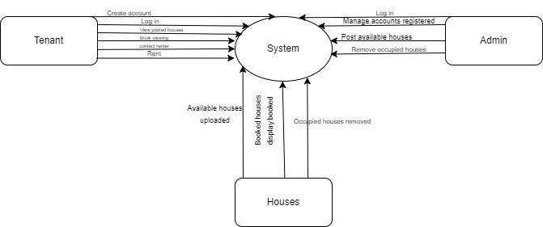

Figure 4 Conceptual framework

# Chapter 3: Research Methodology

## 3.1: Introduction

This chapter provides an overview of the Software Development Methodology applied in the development of the proposed project (Home Finds You). For this system Object-Oriented Analysis and Design (OOAD) is chosen to be applied because it provides a structured and systematic approach to analyzing and designing systems, making the development process more organized and efficient. It is a methodology that focuses on analyzing and designing a system using object-oriented principles, but it can be implemented within various broader system development methodologies.

Iterative and Incremental Development will be applied since the methodology involves developing the system through repeated cycles (iterations) and in smaller portions at a time (increments). Each iteration builds upon the previous one, gradually improving and expanding the system.

## 3.2: Iterative and **Incremental** development methodology

The applied development approach used is the Agile Methodology. This is an iterative and incremental approach and emphasizing adaptability. It is well-suited for this project prioritizes flexibility, collaboration, and customer feedback. They focus on delivering small, incremental improvements to the software. It enhances flexibility to incorporate changes and improvements in each iteration.



Figure 5 Iterative development methodology

### 3.2.1: Requirements Engineering

The main method that will be employed in collecting comprehensive data is analyzing existing accommodation systems for inspiration and to understand their operations and gaps for the proposed system to work on.

### 3.2.2 System Design

The system will use Unified Modelling Language (UML) which provides a standardized way to represent the system’s design. The following diagrams will be used to show how the proposed system will work: use- case diagrams, class diagram, activity diagram, data base schema and sequence diagram. The Use-case diagram will illustrate the functional requirements of a system by showing users and their interactions with use cases (system functionalities). Sequence Diagram depicts the sequence of interactions between objects in a particular scenario of a use case. Activity diagram visually represents the flow of activities/actions in the system. Class diagrams provide the structure of the system. It shows the system classes, attributes, methods and relationships. Database schema manages and stores the data that the system processes and interacts with. Wire frames visual representation that outlines the basic structure and layout of a user interface without delving into the details of design, color, or content.

### 3.2.3 System Development

The proposed system is going to be a web-based system to enable locating of a vacant house efficiently. The following tools will be used collectively to support the efficient implementation, deployment, and maintenance of the system, ensuring a robust and scalable application.

For the front end,

HTML will be used for Prototyping and UI Design it aids in creating visual representations of the user interface, documentation facilitates the creation of interactive and accessible design documentation, web development for the front-end implementation of web-based systems designed using OOAD principles. Integration bridges the front-end (HTML) and the back end designed through OOAD. Define and structure content on the web pages. Visual studio for coding, debugging and testing. CSS (cascading style sheets) to style and define the layout of the web pages created. JavaScript as the programming language.

For the back end, Python (Django) for requirement analysis; define use cases and identify the main objects (classes) in the system. system design to create class diagrams and sequence diagrams to visualize the system's structure and behavior, implementation; use Python and a framework like Django to implement the classes, following the design specifications and ensure the code adheres to object-oriented principles and practices, testing write unit tests for individual classes and methods. perform integration testing to ensure that components interact correctly. deployment of the application to a web server.

### 3.2.4 Testing

Evaluating the web application built using OOAD principles will involve majorly black box testing, unit testing, integration testing, functional testing, acceptance testing and performance testing. This ensures that the application is reliable, meets requirements, secure and works efficiently. be used to support these testing activities, chosen for their reliability and industry standards. This method involves testing a system with no prior knowledge of its internal workings. A tester provides an input, and observes the output generated by the system under test. This makes it possible to identify how the system responds to expected and unexpected user actions. The advantage of using this method is that it allows anyone who does not have technical skills to test the system

## 3.3 Implementation

Once the final system is developed, it is tested severally and deployed to production after assurance of efficient function. The system underwent routine maintenance for minimizing downtime and prevent large-scale failures.

## 3.4 Deliverables

This explains how the system’s modules work together to create a comprehensive, efficient, and user-friendly system that meets the needs of both clients/renters and tenants/ contractors.

### 3.4.1 System Modules

User Interface Module that provides the front-end interface for users to interact with the system: Navigation, dashboards, input filter interface.

Input filter interface that manages all aspects of the preferred house searching; filter selection (rent range, type, number of rooms, location) modification, cancellation, and confirmation generation.

Database Management module that manages the storage, retrieval, and maintenance of all system data: liked houses, destinations, safety policies, attractions, availability, booking and communication history.

Security Management module that ensures the system's security and protects user data: User authentication, authorization and encryption.

Integration module that ensures seamless integration with other systems and services.

### 3.4.2 Users and User roles

Users:

i.Admin

ii. Tenants

User roles:

Admin

1. Log in and manage created accounts
2. Upload available houses
3. Manage house details and availability
4. Handle reservations for viewing

Tenant

1. Create account and log in
2. Search for desired house
3. Maintain polices and meet terms and conditions
4. Book house for viewing
5. Contact renter and possibly occupy house

### 3.4.3 System Architecture

The system structure will comprise of several interconnected components that work together to facilitate various functionalities and processes. Here's an overview of the system structure:

The frontend interface is accessed through web browsers and provides users with the interface to interact with the system, including browsing filters, managing preferences/ filters, and accessing personalized recommendations according to filter input.

The backend server is responsible for processing user requests, booking processing for viewing, managing data, user profiles and the system.

The system includes authentication mechanisms and security measures to ensure the system's integrity.

# Chapter 4: System Analysis and Design

## 4.1 Introduction

This chapter illustrates the system and its design including the system diagrams. Home Finds You will use Object Oriented Analysis and Design (OOAD). This is an iterative process that involves multiple cycles of analysis, design, implementation and testing to refine the system until it meets all the requirements.

**4.2 System Analysis**

These are categorized into functional and nonfunctional requirements

### 4.2.1 Functional Requirements

Functional requirements describe the functionality and services provided by the system.

1. User Authentication**-** Users should be able to create user profiles when it is their first time accessing the system. The system must allow users to log in and log out of the system.
2. Data Management**-** The system must allow users to create, key in, read, update, and delete data.
3. Results**-** The system must generate results based on user inputs.
4. Search Functionality**-** Users must be able to search for items using keywords and filters/ electives set.

### 4.2.2 Non-Functional Requirements

Nonfunctional requirements describe the operational characteristics of the system and are often considered constraints or quality criteria.

1. Performance**-** The system should handle a certain rate of transactions per second or minute. E.g. 1000 transactions per minute.
2. Scalability**-** The system must be able to scale to support a certain number of concurrent users. E.g. 1000 concurrent users.
3. Usability**-** The system should have a simple interface that can be learned within 10 minutes.
4. Reliability**-** The system should have an uptime of 99.9% and accessible 24/7.
5. Security**-** Data should be encrypted both in transit and at rest.

## 4.3 System Design

System design is the process of defining the components, modules, interfaces, and data for a system to satisfy specified requirements. The design or diagrams that were used in defining and developing this project are use case and sequence diagram, activity diagrams, class diagrams, database schema and wire frames.

## 4.4 System Analysis Diagrams

System analysis diagrams are diagrams used to capture high level processes and early models of system behaviour and elements. They provide a useful means of capturing the essential system characteristics and requirements.

A system diagram is a visual model of a system, its components, and their interactions. With supporting documentation, it can capture all the essential information of a system’s design.

## 4.5 System Design Diagrams

A system design diagram is a visual model of a system, its components, and their interactions. With supporting documentation, it can capture all the essential information of a system’s design.

### 4.5.1 Use Case Diagram

A use case diagram is a depiction of interactions among different elements in a system. Use case diagrams specify the events in a system and show how those events flow. It also depicts the users within the system. The use case below is for a house finding system.

# 

Figure 6 Use case diagram

### 4.5.2 System Sequence Diagram

The below diagram shows the order of activities in the system from the admin to the tenants looking for a house. It describes the different processes of the system. The arrows in the diagram show the flow of message from one object to another.

Figure 7 Sequence diagram

### 4.5.3 Activity diagram

An activity diagram visually presents a series of actions or flow of control in a system like a flowchart or a data flow diagram. They also describe the steps in a use case diagram. Activities modelled are sequential and concurrent flowing from one to another.

Figure 8 Activity diagram

### 4.5.4 Class Diagram

The below diagram depicts the classes for the web-based System for House finding. Each class has two main things attributes and functions in that class. The diagram provides detailed insight on the structure of the system.

Figure 9 Class diagram

### 4.5.5 Database Schema

Figure 10 Database schema

### 4.5.6Wireframe

A Wireframe is a blueprint and visual guide that represents the skeletal framework of a website depicting the interfaces.

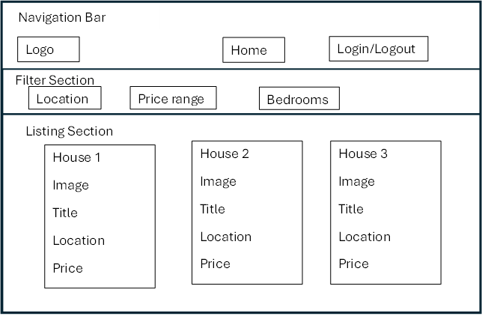

Figure 11 Wireframe skeleton

Figure 12 Wireframe

# ` Chapter 5: System Implementation Testing

## 5.1 Introduction

System implementation testing is the process of testing implementations of system specifications. This process verifies that the specification is implementable in practice, and that implementations conform to the specification. It also helps to improve the quality and interoperability of implementations. This chapter describes the way the system was developed along with the tests done on it.

## 5.2 System Implementation

The system was implemented with the help of Visual Studio Code using Python language. CSS was also used to apply consistent styling of elements across all pages in the system. SQLite was used to store text and image data from the system. The register and login pages were developed first for authentication of email and password, after which the bulk of the system was created.

### 5.2.1 Systems backend

The system’s backend comprises of the logic behind the main functionalities of the supply chain management system as shown below.

1. Login sessions

The below screenshot shows the user types of each user in the system and how they are redirected to their specific home pages after a successful login. Below are the admin log in and user log in code snippets respectively.

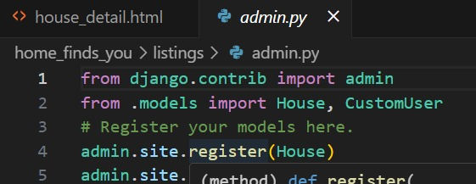

Figure 13 Admin log in code snippet

Figure 14 User log in code snippet

1. Admin view and managing users

In the below screenshot, the admin can view and manage the users accounts by being able to edit or delete the accounts created by the users where need be. Only the admin can be able to do that or the user themselves.

Figure 15 Admin view code snippet

### 5.2.2 System’s front end

The system’s frontend comprises of the logic behind creating the user interface of the system as shown below.

1. Home page

The below screenshot shows how the user interface for the home page was designed. It illustrates how HTML and CSS was used to come up with the home page.

Figure 16 Home page code snippet

1. Admin Dashboard

The below screenshot shows how the super-admin’s interface was designed.

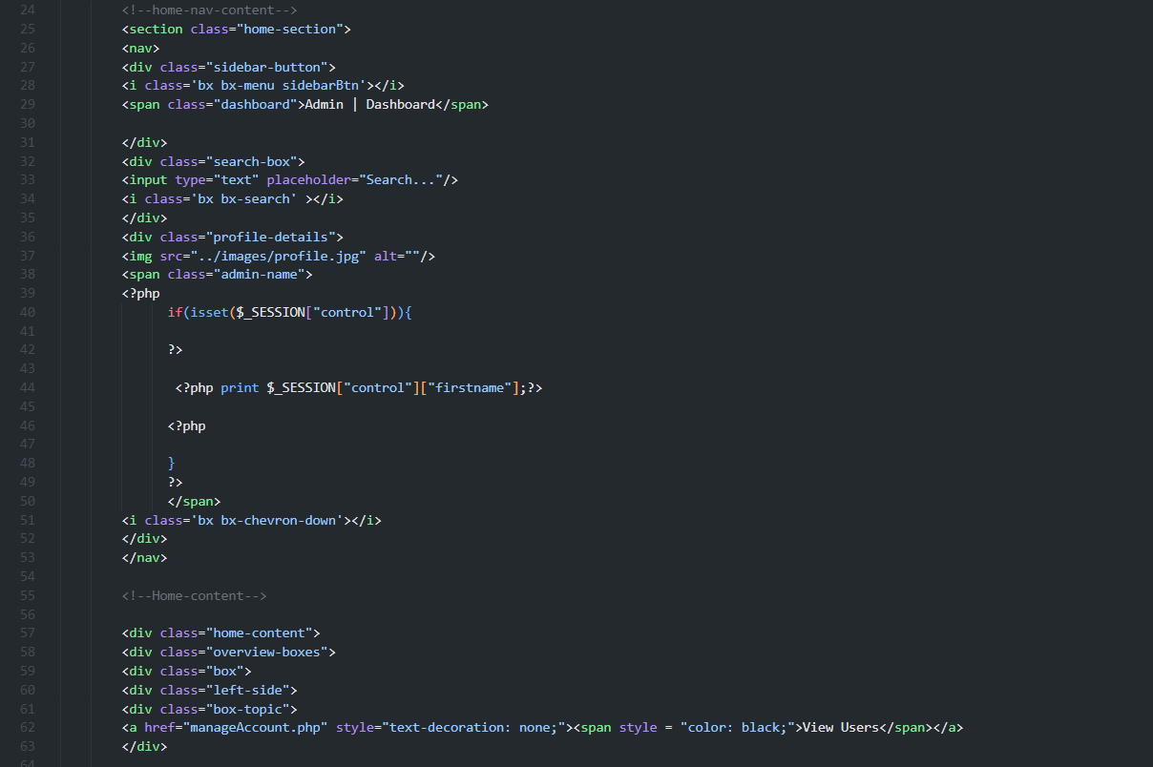

Figure 17 Admin dashboard code snippet

1. Users dashboard

The below screenshot shows how the users’ interface for the house details. It demonstrates how HTML and CSS was used to come up with the user interface in the dashboard.

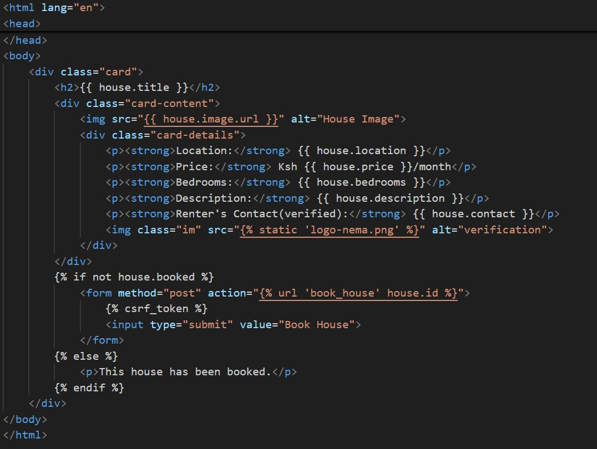

Figure 18 User dashboard code snippet

## 5.3 System manual

The Housing system home page is as in the figure below. It allows users to create accounts, authenticate their information and view uploaded houses.

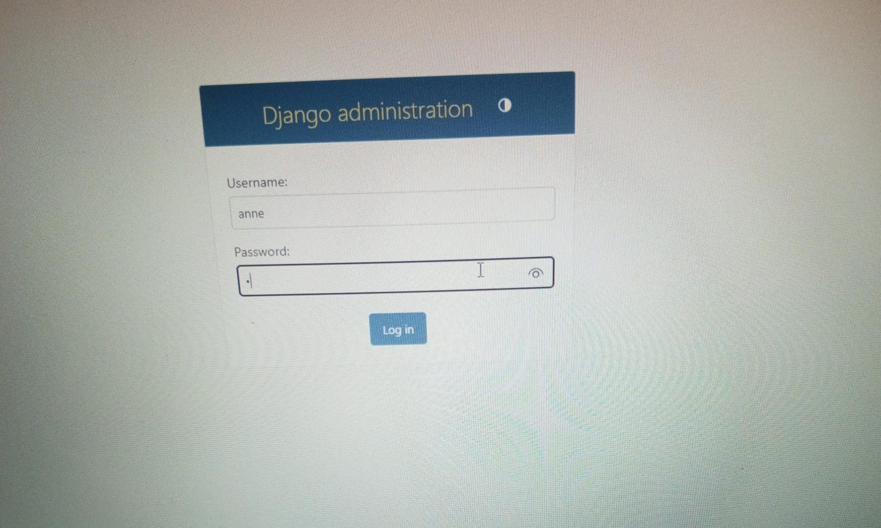

Figure 19Admin log in site

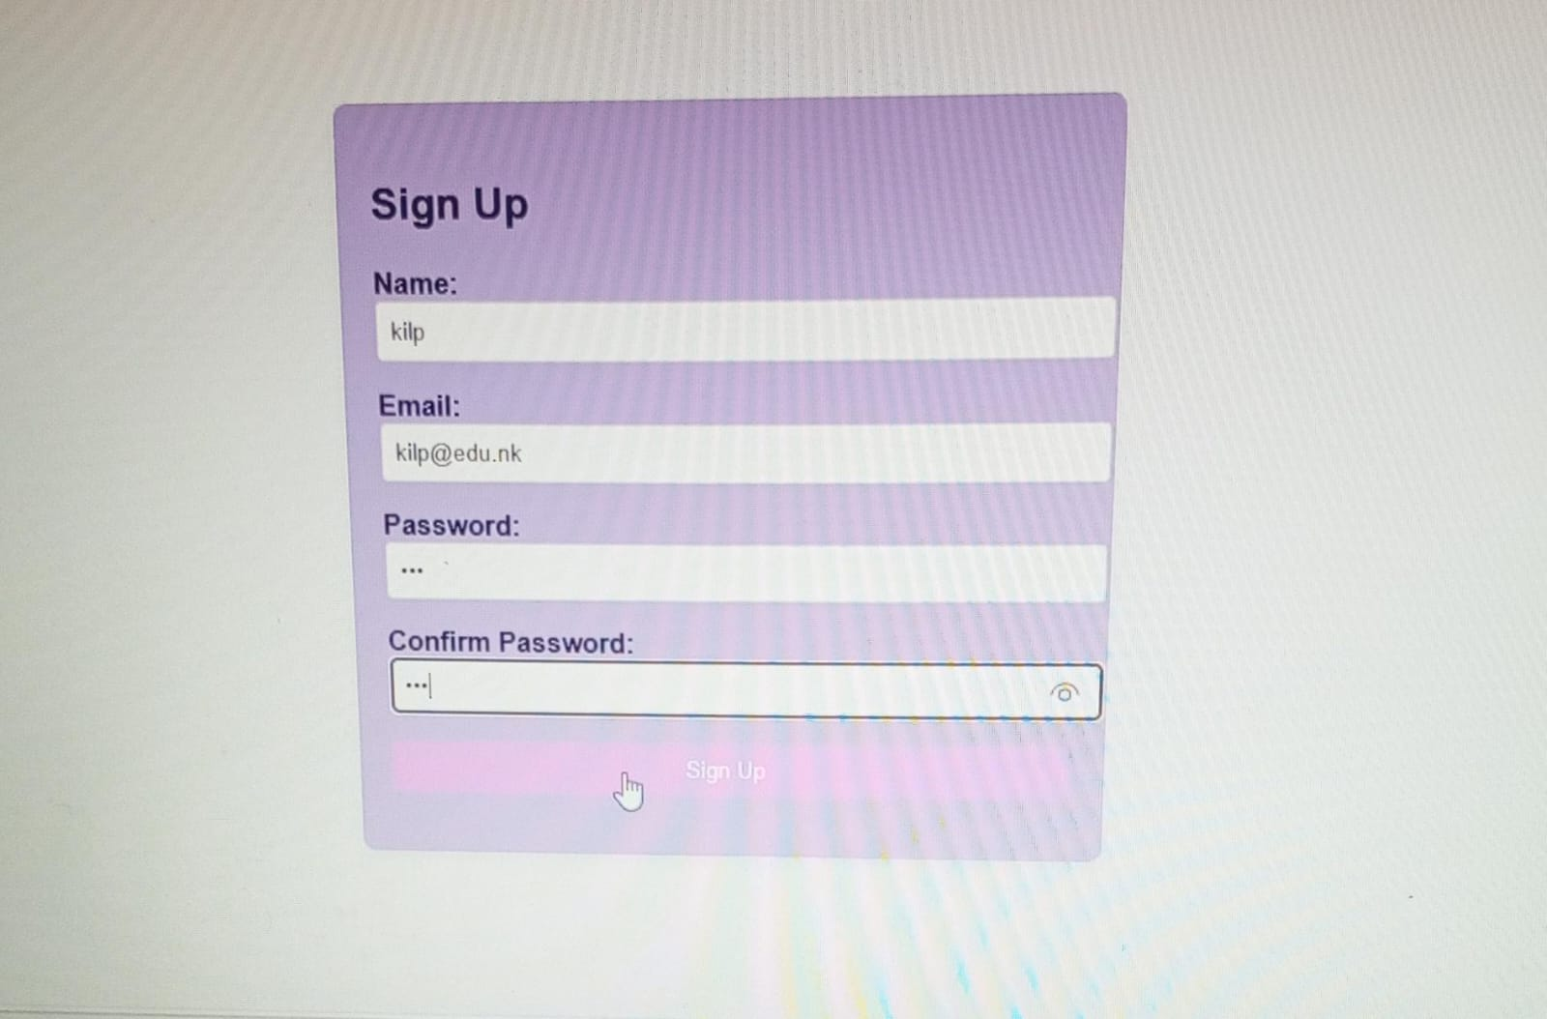

Figure 20User registration

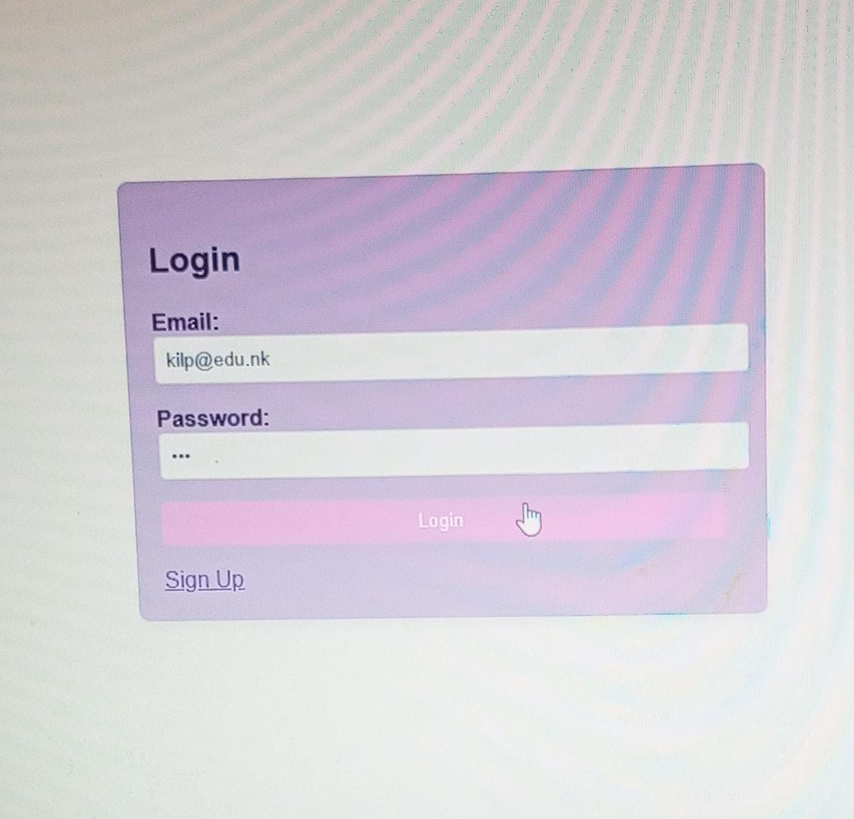

Figure 21 User log in

### 5.3.1 Admin screen

The admin can only access this page after a successful login. They have access to accounts registered and can manage them effectively. The administrator uploads the houses on the system and can remove them as well.

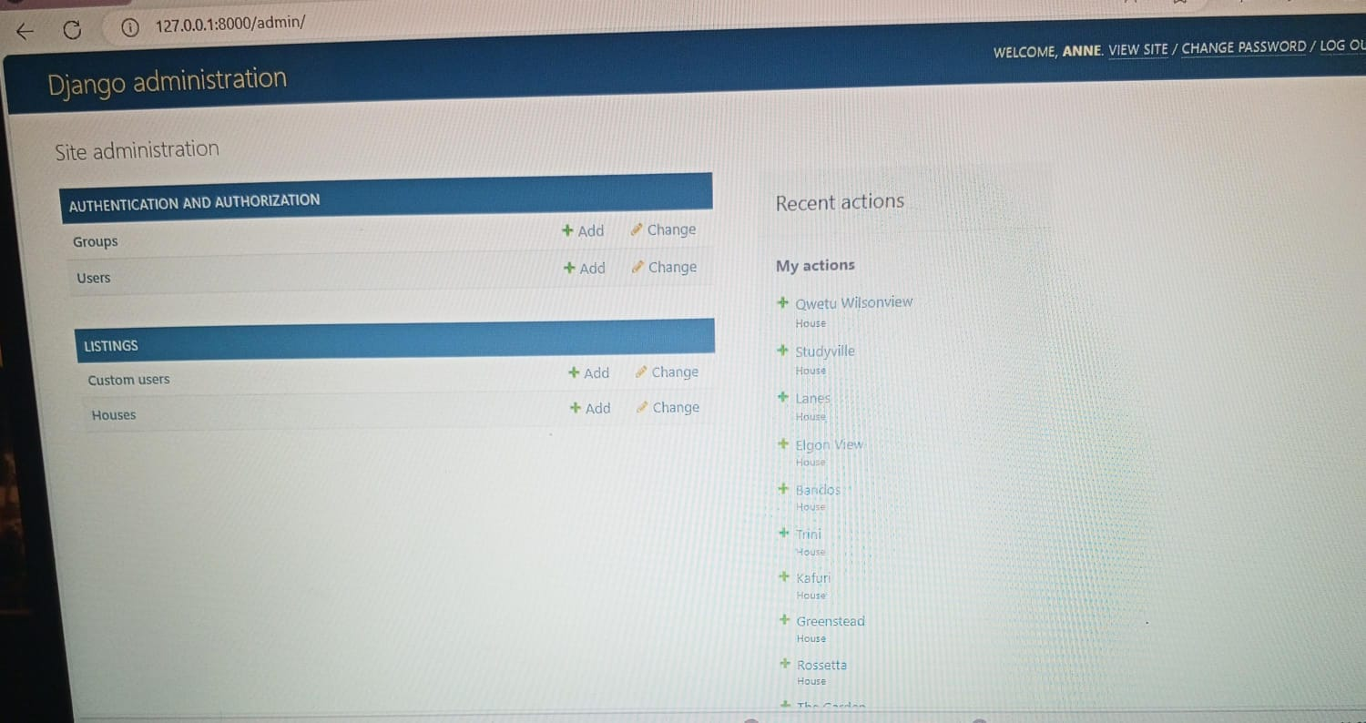

Figure 22 Admin screen

### 5.3.2 User screen

The user can login after successful registration and view uploaded houses as well as the prices. They can search for desired specifications on the filters on the dashboard and a house will be displayed accordingly. Users can also log out after use.

Figure 23 Users homepage

Figure 24 House details

## 5.4 System Testing

This section focuses on the system, what it does and whether the requirements of the system have been met. The testing assists in the detection of system failures and defects enabling rectification or suitable changes.

### 5.4.1 Black box testing

Black Box Testing was used on the system to check the usability of the system from the user’s point of view. The system was developed with the objective of having an interactive user interface that is low in complexity and easy to understand and use.

### 5.4.2 Functionality testing

The system satisfies all the functional requirements by allowing users to create accounts and view uploaded houses. Only authorized users/people with valid accounts can log in to the system. The system also allows users to log out successfully. It also allows the administrator to approve or delete accounts created by users. The administrator uploads the houses on the application, and they are removed when occupied. The system can search the information that users input in the search filter and display available houses accordingly.

### 5.4.3 Unit testing

Unit testing is a kind of testing where the individual functions of the system are tested to confirm they are working correctly. Functions such as log in, registration will be evaluated.

## 5.5 Test Cases

Table 1: Test Cases

|  |  |  |  |
| --- | --- | --- | --- |
| Test Case # | Description | Test Data | Expected  Outcome |
| Registration test | Registration with all required information’s | Field form | Registration must be successful |
| Registration without filling all required field | Registration must not be successful |
| Login test | Login with right credentials | Username  Password | Login must be successful |
| Login with wrong credentials | Login must not be successful |
| View product | Check product | Uploaded product | Uploaded product must be seen |

## 5.6 Test Results

Table 2: Test Results

|  |  |  |  |  |  |
| --- | --- | --- | --- | --- | --- |
| Test Case # | Description | Test Data | Expected Outcome | Actual Result | Verdict (Pass or Fail) |
| Login test | Login with right credentials | Username  Password | Login must be successful | Login successfully | Pass |
| Login with wrong credentials | Login must not be successful | Login failed invalid username or password | Fail |
| View product | Check product | Uploaded product | Uploaded product must be seen | Successful | pass |

# Chapter6: Conclusions and Recommendations for Future Work

## 6.1 Conclusions

Home Finds You system aims to improve the process of finding a suitable abode for citizens as well as create development and job opportunities at large. There is a cause for concern in the settlement and employment sector of the nation and this project aims to elevate this situation one step at a time or rather one home at a time. Through the system house hunting and settling will be much more efficient and as the system grows, the mission is to ensure every citizen has access to proper housing and settlement. To review this problem, the developed system solves the stated problems, contrary to the previous system that lacks these features as long-term solutions.

## 6.2 Recommendations

For the system to function properly, good web browsers such as Chrome, Mozilla and Safari are recommended. Devices that are to be used to access the system should be connected to the internet for the system to function. One should have a working email address for registration and log in.

## 6.3 Future Work

The system is functional in efficient location of housing and settlement options in Nairobi, as the system gains popularity and momentum functionalities such as more counties/ locations, more houses and apartments and different housing options could be added into the system to further improve on it. The system could also collaborate with the existing solutions to create a more integrated interface. The system may be improved by the implementation of contractor and architectural approval and advertisement options whereby contractors could use that site to advertise and build real estates/gated communities and estates thereby bring their visions to life. Luxury living such as maisonettes and luxury homes/ estates could also be brought to life here. The government could also be part of the vision by ensuring the contractors/ renters and everyone involved are cleared and certified according to the construction laws of Kenya. Contractors and renters will be required to upload the documentation as proof of certification and legal registration of the land; issued by the government, this to reduce the probability of working with non-verified firms and frauds. (Construction&Occupation laws, 2024). The system can also be improved adding an in-app chat box and communication interface for direct communication in the app and two-factor authentication to protect the user’s data a notch higher.

# References

2019 Kenya Population and Housing Census Reports - CAHF | Centre for Affordable Housing Finance Africa

https://www.knbs.or.ke/?wpdmpro=2019-kenya-population-and-housing-census-volume-iv-distribution-of-population-by-socio-economic-characteristics

Kenya's Affordable Housing Programme: Delivery framework and policy interventions - CAHF | Centre for Affordable Housing Finance Africa

https://pubmed.ncbi.nlm.nih.gov/28963007/

Liautaud, B., & Hammond, M. (2001). e-Business Intelligence, New York: Mc-Graw Hill.

Liu, W., & Meng, X. (2006). Web Database Inte`gration, Seoul: Proceedings of the VLDB2006 Ph.D. Workshop, 2006

https://www.google.com/search?q=accommodation+nairobi&oq=accommodation&gs_lcrp=EgZjaHJvbWUqCggBEAAYkgMYgAQyEggAEEUYORiDARixAxjJAxiABDIKCAEQABiSAxiABDINCAIQABiSAxiABBiKBTIHCAMQABiABDIHCAQQABiABDIHCAUQABiABDIHCAYQABiABDIHCAcQABiABDIHCAgQABiABDIHCAkQABiPAtIB

https://www.fedan.co.ke/hotel-hospitality-industries.html

http://erepository.uonbi.ac.ke/handle/11295/97753

http://erepository.uonbi.ac.ke/handle/11295/97753

https://www.kenyageographic.com/the-dark-side-of-short-term-rentals-in-kenya/

https://www.scitcentral.com/article.php?journal=47&article=2888&article_title=EVALUATION%20OF%20THE%20EFFECTS%20OF%20INSECURITY%20ON%20THE%

https://www.airbnb.com/nairobi-kenya/stays

https://cloudhotelsuites.com/

https://intuji.com/airbnb-tech-stack-explained-airbnb-app/ https://www.mews.com/en/solutions/hostel-management-system#:~:text=Many%20hostel%20property%20management%20systems,up%20as%20a%20cloud%20technology.

https://za.hotels.com/de1634171/nairobi-kenya-hotels-rooms/

https://www.nema.go.ke/

https://www.eastafricanexperience.com/nairobi

https://khweza.com/

https://aretecarehospital.com/understanding-construction-laws-in-kenya-key-regulations-and-requirements/#:~:text=The%20Occupational%20Safety%20and%20Health,at%20construction%20sites%20in%20Kenya

# Appendix A: Gantt Chart



